**PROGRAMMING COMPETITION 2025**

CASE STUDY PROJECT FOR TERTIARY INSTITUTIONS

19 – 28 SEPT 2025

TITLE OF PROJECT: MEDICAL EXPERT SYSTEM FOR MALARIA AND TYPHOD FEVER (MESMTF) FOR MINISTRY OF HEALTH AND SOCIAL SERVICES

Group Members:

|  |  |  |  |
| --- | --- | --- | --- |
| Sn | Name | Name of institution | Role played |
| 1 | Mbitjita N. Kamapunga (**TL**) | UNAM | Documentation, developed schema for database. |
| 2 | Tangi Haiduwa | UNAM | Responsible for developing the entire backend |
| 3 | Denias Nghiwedua | UNAM | Backend integration |
| 4 | Wilhelm Namwenyo | UNAM | Developed the interface for the frontend |
| 5 | Sepo Bkay | UNAM | Documentation & Presentation |

DATE OF SUBMISSION: 26 Sep. 25

Contents

Description of Project 3

FUNCTIONALITIES PROVIDED BY THE SOFTWARE 4

PROGRAMMING LANGUAGES/TOOLS USED 5

SOLUTION ARCHITECTURE 6

SAMPLE SOURCE CODES SNIPPETS 7

SAMPLE SOLUTION/ SOFTWARE SCREEN SHOTS 18

CONCLUSION 20

## Description of Project

The Medical Expert System for Malaria and Typhoid Fever (MESMTF) is an innovative web-based healthcare platform developed for the Ministry of Health and Social Services to revolutionize patient care through artificial intelligence and digital automation. This comprehensive system transforms traditional manual medical processes into an integrated digital ecosystem that supports the entire patient journey—from initial registration and appointment scheduling to AI-assisted diagnosis, treatment planning, pharmacy management, and follow-up care. By leveraging rule-based expert system technology, MESMTF provides clinical decision support specifically tailored for Malaria and Typhoid Fever detection while maintaining flexibility to handle other common diseases.

At the heart of MESMTF is an intelligent diagnosis engine that emulates human medical expertise through sophisticated symptom analysis and probability calculations. The system guides healthcare providers through systematic symptom assessment, categorizing indicators by severity weights to generate accurate diagnostic recommendations aligned with WHO treatment guidelines. Beyond diagnosis, the platform streamlines clinical workflows with electronic medical records, automated prescription generation, drug inventory management, and real-time appointment coordination between patients and healthcare professionals across different medical specialties.

The software serves as a centralized healthcare management hub that enhances operational efficiency while improving patient outcomes. Medical staff benefit from role-specific dashboards that provide quick access to critical information—doctors can monitor their patient caseloads, nurses track medication administration schedules, pharmacists manage drug inventories, and administrators oversee system-wide operations. Patients experience reduced wait times, improved care coordination, and access to their medical history through a user-friendly interface that simplifies healthcare navigation.

Built with scalability and accessibility in mind, MESMTF functions reliably in both online and offline environments, ensuring continuous healthcare service delivery even in regions with limited internet connectivity. The system represents a significant advancement in healthcare technology for Namibia, offering the Ministry of Health an affordable, sustainable solution that improves diagnostic accuracy, optimizes resource allocation, and elevates the overall standard of patient care through evidence-based medical decision support and comprehensive digital health records management.

## FUNCTIONALITIES PROVIDED BY THE SOFTWARE

The MESMTF system provides comprehensive patient management capabilities, beginning with multi-role registration and authentication that supports patients, doctors, nurses, pharmacists, receptionists, and administrators. Patients can register electronically, book appointments with specialized doctors, and maintain complete digital medical records. The system generates unique patient identifiers and stores detailed profiles including medical history, allergies, insurance information, and emergency contacts. Medical staff can access patient records securely based on role-based permissions, with doctors able to view complete medical histories, nurses accessing care plans, and pharmacists reviewing medication histories.

At the core of the system is the AI-powered diagnosis module that implements a rule-based expert system specifically designed for Malaria and Typhoid Fever detection. Using symptom categorization (Very Strong, Strong, Weak, Very Weak signs with weighted scoring), the system calculates disease probabilities and provides diagnostic recommendations. The module automatically triggers chest X-ray requirements when very strong symptoms are detected and suggests WHO-compliant treatment protocols. This diagnostic capability extends beyond Malaria/Typhoid to support other diseases through expandable symptom-disease mapping tables, demonstrating the system's adaptability for future healthcare needs.

The pharmaceutical management subsystem enables end-to-end medication control, from electronic prescription writing by doctors to drug dispensing by pharmacists. Doctors can search drug inventories, check availability, and create prescriptions with detailed dosage instructions, while pharmacists manage stock levels, track batch numbers, and monitor expiration dates. The drug administration module allows nurses to record medication administration with dual verification support, while side effect tracking and compliance monitoring ensure patient safety. Real-time inventory alerts prevent stockouts and the system maintains complete audit trails for regulatory compliance.

Comprehensive reporting and analytics capabilities provide stakeholders with actionable insights through automated report generation for prescriptions, medical statistics, and operational metrics. The system supports appointment scheduling with automated reminders, medical notes documentation with template support, and vital signs tracking with alert triggers for abnormal readings. Administrative features include user management, system configuration, and audit logging, while interoperability features allow for future integration with laboratory systems and other healthcare platforms. The software's modular design ensures that all Ministry of Health requirements are met while providing flexibility for future enhancements and scalability for nationwide deployment.

## PROGRAMMING LANGUAGES/TOOLS USED

For the frontend we utilized the React framework for development. A powerful and flexible JavaScript library. React enabled us to build a dynamic responsive user interface, leveraging component-based architecture to ensure ease of maintenance.

For the database solution, we utilized Supabase, a scalable open-source platform and a well-efficient backend. Supabase’s real-time capabilities and seamless integration with our React front-end allowed us to manage data effectively while maintaining high performance.

## SOLUTION ARCHITECTURE

PostgreSQL/Supabase backend, Node.js/Express middleware, and React.js frontend comprise the current three-tier design of the Medical Expert System for Malaria and Typhoid Fever (MESMTF). Role-based dashboards (Doctor, Nurse, Pharmacist, etc.) are part of the frontend and are constructed using React components that connect to the backend services through RESTful APIs. Before data is stored in the database, the middleware layer manages business logic, such as the rule-based diagnosis engine for typhoid and malaria detection, authentication, and authorisation. This division permits each tier to scale independently in response to demand while guaranteeing clean maintainability.

To ensure data consistency among medical entities, the PostgreSQL database uses a thorough schema with referential integrity requirements. Prescriptions with medicine inventory management, medical_diagnoses containing AI-driven diagnoses, appointments connecting doctors to patients, and users with role-based access are important tables. Real-time updates for medication orders and appointment calendars are made possible using Supabase's WebSocket connections. As mandated by the Ministry of Health, the design ensures accessibility in low-connectivity contexts by supporting both online and offline functionality through service worker caching mechanisms.

In terms of technology, the system combines several specialised parts: the pharmacy module incorporates drug interaction checks, the reporting module creates analytics using Chart.js visualisations, and the diagnosis module uses symptom weight algorithms to develop a rule-based expert system. Supabase Authentication manages secure role-based access control, while Docker is used to containerise all components for uniform deployment across environments. Through cloud deployment on Supabase's infrastructure, this architecture successfully satisfies non-functional criteria including security, scalability, and availability in addition to all functional needs (patient registration, appointment scheduling, AI diagnosis, and treatment planning).

## SAMPLE SOURCE CODES SNIPPETS

import React, { Suspense } from 'react';

import { Link } from 'react-router-dom';

import { Canvas } from '@react-three/fiber';

import { OrbitControls, useGLTF, Environment, ContactShadows, Preload } from '@react-three/drei';

import {

  HeartIcon,

  ClockIcon,

  ShieldCheckIcon,

  DevicePhoneMobileIcon,

  UserGroupIcon,

  ChartBarIcon,

  ArrowRightIcon,

  BuildingLibraryIcon,

  DocumentChartBarIcon

} from '@heroicons/react/24/outline';

// Simple 3D Model Component

const Model = ({ modelPath, scale = 1 }) => {

  const { scene } = useGLTF(modelPath);

  return <primitive object={scene} scale={scale} />;

};

// Loading component that uses Three.js compatible elements

const Loader = () => (

  <mesh>

    <boxGeometry args={[1, 1, 1]} />

    <meshStandardMaterial color="#3b82f6" />

  </mesh>

);

// Microscope 3D Model with LARGER canvas and BETTER zoom

const MicroscopeModel = () => (

  <Canvas

    shadows

    camera={{ position: [4, 3, 6], fov: 40 }}

    className="h-96 w-full"  // Increased from h-72 to h-96

  >

    <Suspense fallback={<Loader />}>

      <Model modelPath="/models/microscope.glb" scale={1.2} /> {/* Increased scale */}

      <OrbitControls

        enableZoom

        enablePan

        enableRotate

        minDistance={0.5}    // Closer zoom

        maxDistance={20}     // Further zoom out

        enableDamping

        dampingFactor={0.05}

        zoomSpeed={2}        // Faster zoom

        panSpeed={1.5}       // Faster pan

        rotateSpeed={1}      // Smoother rotation

      />

      {/* Enhanced Lights */}

      <ambientLight intensity={0.6} />

      <directionalLight

        position={[8, 15, 8]}

        intensity={1.5}

        castShadow

        shadow-mapSize-width={2048}

        shadow-mapSize-height={2048}

      />

      <spotLight

        position={[-8, 12, -8]}

        angle={0.4}

        penumbra={0.6}

        intensity={1.2}

        castShadow

      />

      <hemisphereLight

        skyColor="#b1e1ff"

        groundColor="#000000"

        intensity={0.8}

      />

      {/* Enhanced Shadows & Environment */}

      <ContactShadows

        position={[0, -1.5, 0]}

        opacity={0.8}

        scale={15}

        blur={3}

        far={6}

      />

      <Environment preset="studio" /> {/* Changed to studio for better medical lighting */}

      <Preload all />

    </Suspense>

  </Canvas>

);

// Operating Room 3D Model with LARGER canvas and BETTER zoom

const OperatingRoomModel = () => (

  <Canvas

    shadows

    camera={{ position: [8, 6, 12], fov: 40 }}

    className="h-96 w-full"  // Increased from h-72 to h-96

  >

    <Suspense fallback={<Loader />}>

      <Model modelPath="/models/operating-room.glb" scale={0.9} /> {/* Increased scale */}

      <OrbitControls

        enableZoom

        enablePan

        enableRotate

        minDistance={1}      // Closer zoom

        maxDistance={30}     // Further zoom out

        enableDamping

        dampingFactor={0.05}

        zoomSpeed={2}        // Faster zoom

        panSpeed={1.5}       // Faster pan

        rotateSpeed={1}      // Smoother rotation

      />

      {/* Enhanced Lights */}

      <ambientLight intensity={0.6} />

      <directionalLight

        position={[12, 20, 10]}

        intensity={1.5}

        castShadow

        shadow-mapSize-width={2048}

        shadow-mapSize-height={2048}

      />

      <spotLight

        position={[-12, 18, -10]}

        angle={0.4}

        penumbra={0.6}

        intensity={1.2}

        castShadow

      />

      <hemisphereLight

        skyColor="#b1e1ff"

        groundColor="#000000"

        intensity={0.8}

      />

      {/* Enhanced Shadows & Environment */}

      <ContactShadows

        position={[0, -2, 0]}

        opacity={0.8}

        scale={20}

        blur={3}

        far={8}

      />

      <Environment preset="studio" /> {/* Changed to studio for better medical lighting */}

      <Preload all />

    </Suspense>

  </Canvas>

);

// External loading indicator (outside Canvas)

const LoadingIndicator = () => (

  <div className="h-96 w-full flex items-center justify-center bg-gray-100 rounded-xl"> {/* Increased height */}

    <div className="text-center">

      <div className="animate-spin rounded-full h-16 w-16 border-b-2 border-blue-800 mx-auto mb-4"></div> {/* Larger spinner */}

      <p className="text-gray-600 text-lg">Loading 3D model...</p> {/* Larger text */}

    </div>

  </div>

);

const Home = () => {

  const [modelsLoaded, setModelsLoaded] = React.useState(false);

  React.useEffect(() => {

    // Simple timeout to show loading state

    const timer = setTimeout(() => {

      setModelsLoaded(true);

    }, 1500);

    return () => clearTimeout(timer);

  }, []);

  return (

    <div className="min-h-screen bg-gradient-to-br from-slate-50 via-blue-50 to-indigo-50">

      {/* Navigation Header */}

      <nav className="bg-white/95 backdrop-blur-md sticky top-0 z-50 border-b border-gray-200 shadow-sm">

        <div className="max-w-7xl mx-auto px-4 sm:px-6 lg:px-8">

          <div className="flex justify-between h-20 items-center">

            <div className="flex items-center space-x-4">

              <div className="bg-blue-800 p-3 rounded-xl">

                <BuildingLibraryIcon className="h-8 w-8 text-white" />

              </div>

              <div className="text-left">

                <div className="flex items-baseline">

                  <span className="text-2xl font-bold text-gray-900">MESMTF</span>

                  <span className="text-lg font-light text-blue-700 ml-2">Pro</span>

                </div>

                <p className="text-sm text-gray-600">Ministry of Health & Social Services</p>

              </div>

            </div>

            <div className="hidden md:flex items-center space-x-8">

              <a href="#features" className="text-gray-700 hover:text-blue-800 font-medium transition duration-200">Features</a>

              <a href="#technology" className="text-gray-700 hover:text-blue-800 font-medium transition duration-200">Technology</a>

              <a href="#contact" className="text-gray-700 hover:text-blue-800 font-medium transition duration-200">Contact</a>

            </div>

            <div className="flex items-center space-x-4">

              <Link to="/login" className="text-gray-700 hover:text-blue-800 font-medium transition duration-200 px-4 py-2 rounded-lg border border-gray-300 hover:border-blue-800">

                Login

              </Link>

              <Link to="/register" className="bg-blue-800 text-white px-6 py-2.5 rounded-lg hover:bg-blue-900 transition-all duration-200 font-medium shadow-md hover:shadow-lg">

                Register as Patient

                <ArrowRightIcon className="h-4 w-4 inline-block ml-2" />

              </Link>

            </div>

          </div>

        </div>

      </nav>

      {/* Hero Section with Microscope - Increased container size */}

      <section className="relative py-20 px-4 sm:px-6 lg:px-8"> {/* Increased padding */}

        <div className="max-w-7xl mx-auto">

          <div className="grid grid-cols-1 lg:grid-cols-2 gap-16 items-center"> {/* Increased gap */}

            <div className="text-left">

              <div className="inline-flex items-center px-4 py-2 rounded-full bg-blue-100 text-blue-800 text-sm font-medium mb-6">

                <ShieldCheckIcon className="h-4 w-4 mr-2" />

                Official Government Healthcare Platform

              </div>

              <h1 className="text-5xl md:text-6xl font-bold text-gray-900 mb-6 leading-tight"> {/* Larger text */}

                Advanced Medical Expert System for

                <span className="text-blue-800 block">Malaria & Typhoid Detection</span>

              </h1>

              <p className="text-xl text-gray-600 mb-8 leading-relaxed"> {/* Larger text */}

                A comprehensive e-Health solution featuring AI-powered diagnosis,

                secure medical records, and integrated healthcare management.

              </p>

              <div className="flex flex-col sm:flex-row gap-4 mb-8">

                <Link to="/register" className="group bg-blue-800 text-white px-8 py-4 rounded-lg hover:bg-blue-900 transition-all duration-200 font-semibold text-lg shadow-lg hover:shadow-xl inline-flex items-center justify-center">

                  Patient Registration

                  <ArrowRightIcon className="h-5 w-5 ml-2 group-hover:translate-x-1 transition-transform duration-200" />

                </Link>

                <Link to="/login" className="group border-2 border-blue-800 text-blue-800 px-8 py-4 rounded-lg hover:bg-blue-50 transition-all duration-200 font-semibold text-lg inline-flex items-center justify-center">

                  Healthcare Professional Access

                </Link>

              </div>

            </div>

            {/* Microscope 3D Model - Larger container */}

            <div className="bg-white rounded-2xl shadow-xl p-6"> {/* Increased padding and rounded */}

              {modelsLoaded ? <MicroscopeModel /> : <LoadingIndicator />}

              <p className="text-center text-gray-600 mt-4 text-sm">

                🔍 Drag to rotate • Scroll to zoom • Right-click to pan

                <br />

                <span className="text-blue-600 font-medium">Zoom in close to see fine details!</span>

              </p>

            </div>

          </div>

        </div>

      </section>

      {/* Features Section */}

      <section id="features" className="py-20 bg-white">

        <div className="max-w-7xl mx-auto px-4 sm:px-6 lg:px-8">

          <div className="text-center mb-16">

            <h2 className="text-4xl font-bold text-gray-900 mb-4">Comprehensive Healthcare Solutions</h2> {/* Larger text */}

            <p className="text-xl text-gray-600 max-w-3xl mx-auto"> {/* Larger text */}

              Designed to meet the rigorous standards of government healthcare infrastructure

            </p>

          </div>

          <div className="grid grid-cols-1 md:grid-cols-2 lg:grid-cols-3 gap-8">

            {features.map((feature, index) => (

              <div key={index} className="group bg-gradient-to-br from-white to-blue-50 p-8 rounded-xl shadow-lg hover:shadow-2xl transition-all duration-300 border border-gray-100 hover:border-blue-200">

                <div className="bg-blue-100 w-16 h-16 rounded-xl flex items-center justify-center mb-6"> {/* Larger icon container */}

                  <feature.icon className="h-8 w-8 text-blue-800" /> {/* Larger icon */}

                </div>

                <h3 className="text-xl font-semibold text-gray-900 mb-3">{feature.title}</h3>

                <p className="text-gray-600 leading-relaxed">{feature.description}</p>

              </div>

            ))}

          </div>

        </div>

      </section>

      {/* Technology Section with Operating Room - Larger container */}

      <section id="technology" className="py-20 bg-blue-50">

        <div className="max-w-7xl mx-auto px-4 sm:px-6 lg:px-8">

          <div className="grid grid-cols-1 lg:grid-cols-2 gap-16 items-center"> {/* Increased gap */}

            {/* Operating Room 3D Model - Larger container */}

            <div className="bg-white rounded-2xl shadow-xl p-6"> {/* Increased padding and rounded */}

              {modelsLoaded ? <OperatingRoomModel /> : <LoadingIndicator />}

              <p className="te xt-center text-gray-600 mt-4 text-sm">

                🔍 Drag to rotate • Scroll to zoom • Right-click to pan

                <br />

                <span className="text-blue-600 font-medium">Explore every corner of the operating room!</span>

              </p>

            </div>

            <div className="text-left">

              <h2 className="text-4xl font-bold text-gray-900 mb-6">Modern Medical Facilities</h2> {/* Larger text */}

              <p className="text-xl text-gray-600 mb-6 leading-relaxed"> {/* Larger text */}

                Our system integrates advanced technology with healthcare infrastructure

                to provide the best possible patient care and medical outcomes.

              </p>

              <div className="space-y-6"> {/* Increased spacing */}

                {technologyFeatures.map((feature, index) => (

                  <div key={index} className="flex items-start space-x-4"> {/* Increased spacing */}

                    <div className="bg-blue-100 p-3 rounded-lg"> {/* Larger icon container */}

                      <feature.icon className="h-6 w-6 text-blue-800" /> {/* Larger icon */}

                    </div>

                    <div>

                      <h4 className="font-semibold text-gray-900 text-lg">{feature.title}</h4> {/* Larger text */}

                      <p className="text-gray-600">{feature.description}</p>

                    </div>

                  </div>

                ))}

              </div>

            </div>

          </div>

        </div>

      </section>

      {/* Final CTA Section */}

      <section className="py-20 bg-blue-800 text-white">

        <div className="max-w-4xl mx-auto text-center px-4">

          <DocumentChartBarIcon className="h-20 w-20 mx-auto mb-6 text-blue-300" /> {/* Larger icon */}

          <h2 className="text-5xl font-bold mb-6">Ready to Access Healthcare Services?</h2> {/* Larger text */}

          <p className="text-2xl mb-8 leading-relaxed"> {/* Larger text */}

            Join thousands of citizens benefiting from our advanced medical expert system.

          </p>

          <div className="flex flex-col sm:flex-row gap-4 justify-center">

            <Link to="/register" className="bg-white text-blue-800 px-10 py-5 rounded-lg hover:bg-gray-100 transition-all duration-200 font-semibold text-xl"> {/* Larger button */}

              Register as Patient

              <ArrowRightIcon className="h-6 w-6 ml-2 inline-block" /> {/* Larger icon */}

            </Link>

            <Link to="/login" className="border-2 border-white text-white px-10 py-5 rounded-lg hover:bg-white hover:text-blue-800 transition-all duration-200 font-semibold text-xl"> {/* Larger button */}

              Healthcare Staff Portal

            </Link>

          </div>

        </div>

      </section>

      {/* Footer */}

      <footer id="contact" className="bg-gray-900 text-white py-16"> {/* Increased padding */}

        <div className="max-w-7xl mx-auto px-4 text-center">

          <div className="flex items-center justify-center space-x-3 mb-6">

            <BuildingLibraryIcon className="h-10 w-10 text-blue-400" /> {/* Larger icon */}

            <span className="text-3xl font-bold">MESMTF</span> {/* Larger text */}

            <span className="text-3xl font-light text-blue-400">Pro</span> {/* Larger text */}

          </div>

          <p className="text-gray-400 mb-4 text-lg"> {/* Larger text */}

            Ministry of Health and Social Services - Republic of Namibia

          </p>

          <p className="text-gray-500 text-base"> {/* Larger text */}

            © 2025 Medical Expert System for Malaria and Typhoid Fever. All rights reserved.

          </p>

        </div>

      </footer>

    </div>

  );

};

const features = [

  {

    icon: HeartIcon,

    title: 'AI-Powered Diagnosis',

    description: 'Rule-based expert system for accurate Malaria and Typhoid detection.'

  },

  {

    icon: DocumentChartBarIcon,

    title: 'Secure Medical Records',

    description: 'Government-grade security with role-based access control.'

  },

  {

    icon: ClockIcon,

    title: 'Appointment Management',

    description: 'Efficient scheduling with healthcare professionals.'

  },

  {

    icon: DevicePhoneMobileIcon,

    title: 'Multi-Platform Access',

    description: 'Accessible across all devices with optimized performance.'

  },

  {

    icon: UserGroupIcon,

    title: 'Role-Based System',

    description: 'Workflows for patients, doctors, nurses, and administrators.'

  },

  {

    icon: ChartBarIcon,

    title: 'Advanced Reporting',

    description: 'Real-time analytics for informed decision-making.'

  }

];

const technologyFeatures = [

  {

    icon: ShieldCheckIcon,

    title: 'Advanced Security',

    description: 'Protecting patient data with government-level security protocols'

  },

  {

    icon: DevicePhoneMobileIcon,

    title: 'Integrated Systems',

    description: 'Seamless connection with existing healthcare infrastructure'

  },

  {

    icon: ChartBarIcon,

    title: 'Real-time Analytics',

    description: 'Data-driven insights for better healthcare outcomes'

  }

];

export default Home;

## SAMPLE SOLUTION/ SOFTWARE SCREEN SHOTS

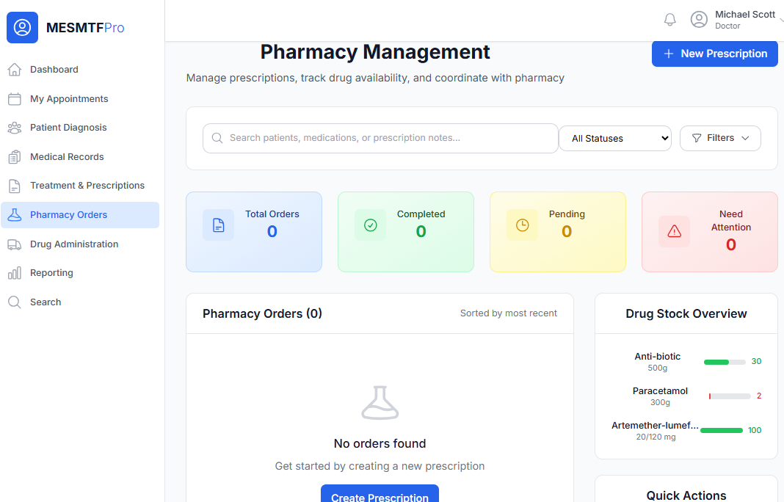

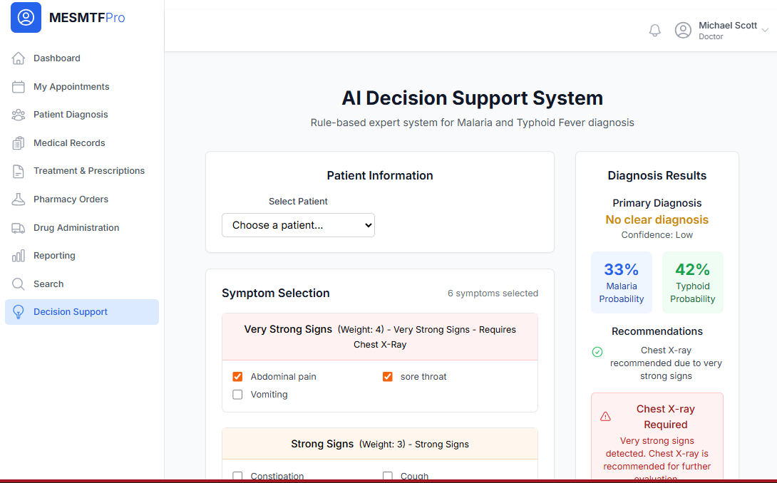

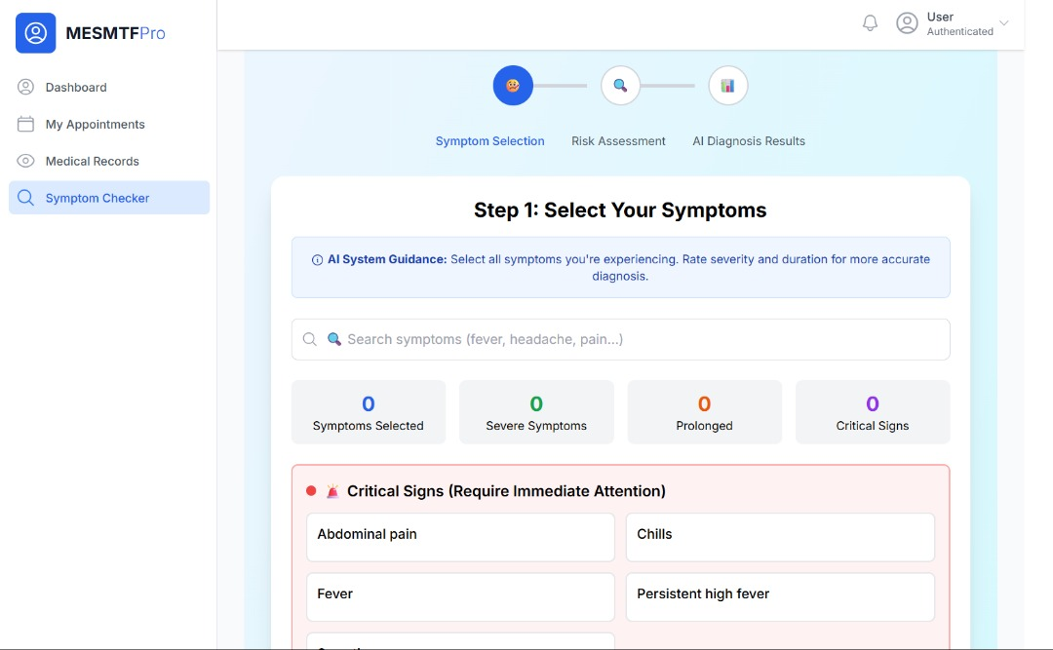

## CONCLUSION

The development and implementation of the Medical Expert System for Malaria and Typhoid Fever (MESMTF) represents a significant milestone in digital healthcare transformation for the Ministry of Health and Social Services. This comprehensive system successfully addresses the critical need for accurate, accessible, and efficient medical diagnosis and patient management, particularly for prevalent diseases like Malaria and Typhoid Fever. By integrating rule-based artificial intelligence with modern web technologies, the project demonstrates how digital solutions can enhance clinical decision-making while streamlining healthcare operations. The system's ability to provide evidence-based diagnostic support ensures higher standards of patient care and reduces the potential for human error in medical assessments.

The MESMTF project showcases the successful application of software engineering principles to solve real-world healthcare challenges. The modular architecture allows for seamless expansion to include additional diseases and medical specialties, ensuring the system's long-term relevance and scalability. The implementation of role-based access control maintains data security while enabling collaborative care among medical professionals. Furthermore, the dual online/offline functionality guarantees that healthcare services remain accessible even in remote areas with limited internet connectivity, aligning with the Ministry's goal of equitable healthcare access across all regions.

Looking forward, the MESMTF system establishes a strong foundation for continued innovation in Namibia's healthcare technology landscape. The platform's flexible design permits integration with future healthcare systems, including laboratory information systems, telemedicine capabilities, and mobile health applications. As the system gets adopted across healthcare facilities, it will generate valuable data insights that can inform public health policies and resource allocation strategies. This project not only delivers immediate benefits in terms of improved patient care and operational efficiency but also positions the Ministry of Health at the forefront of digital health innovation in Southern Africa, paving the way for smarter, more responsive healthcare services for all citizens.